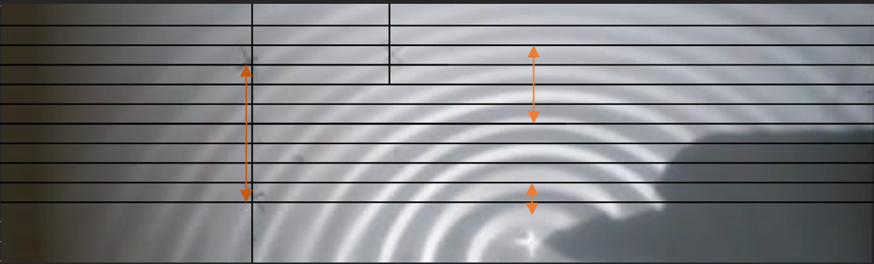

2.86 CM

5CM

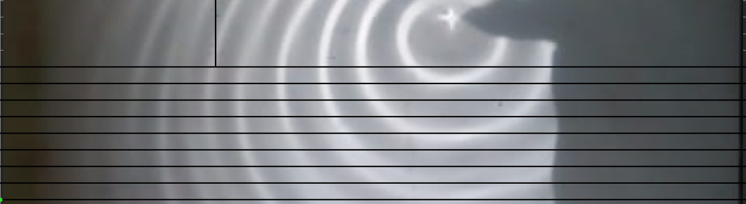

2.6 CM

LAMDA ORGINAL = 1.07 CM

LAMDA SHIFTED = LAMDA 1 = 2.86 CM /3 = 0.95 CM

LAMDA 2 = 2.6 CM (used scale to measure (3.65\*5/7 )

0.95 = (0.21-v)\*1.79/0.21

V= 0.21 -0.111 = 0.099 cm/s

2.6 = (0.21 + v) \*1.79/0.21

V = 0.095

V mean = 0.097 m/s